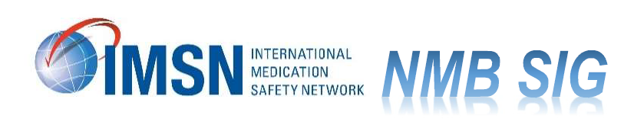
IMSN Neuromuscular Blocker Safety Interest Group (SIG) Charter

Introduction:
Neuromuscular blocking agents are considered high-alert medications because they carry a heightened risk of causing significant patient parm when they are used in error. These drugs are used to paralyze skeletal muscles during anesthesia to facilitate endotracheal intubation and to facilitate mechanical ventilation of critically ill patients. Unfortunately, neuromuscular blockers have a well-documented history of causing significant injury and death when they have been inadvertently administered to patients who were not receiving proper ventilatory assistance. Because neuromuscular blockers paralyze the muscles that are necessary for breathing, some patients have died or sustained serious, permanent injuries if the paralysis was not witnessed by a practitioner who could intervene.

The International Medication Safety Network (IMSN) Executive Committee has proposed development of a Neuromuscular Blocker Safety Interest Group to stimulate global implementation of safe practices that address causal factors of reported medication errors. Recommendations will include those that can be adopted in practice as well as by drug storage equipment vendors, drug manufacturers, and regulatory and standard setting agencies.

Mandates:
The primary objectives of the IMSN Neuromuscular Blockers Safety Interest Group are:
- To share medication errors and safety issues with members regarding the safe use of neuromuscular blockers (NMB)
- To develop comprehensive and global applicable recommendations including a guidance document on safe handling and administration of NMB.
- To engage international partners including The International Society of Pharmacovigilance (ISoP), The Uppsala Monitoring Center (UMC), and the World Health Organization for input and to facilitate implementation of recommendations.

The findings and recommendations will be made publicly available in a specific section of the IMSN website.
Membership
The Neuromuscular Blocker Safety Interest Group (NMB SIG) is co-chaired by Mike Cohen and Christina Michalek. The NMB SIG will consist of IMSN members on a voluntary basis. The IMSN General Secretary will provide input as needed. ISMP fellows will provide support services on an as needed basis.
It is expected the membership will also include patient safety, pharmacovigilance centres, as well as regulatory agencies. Key stakeholders, including WHO, UMC, ISoP, and others will also be invited.
Organization and Communication
Communication and information will be shared among members of the Safety Interest Group in the IMSN website blog:
https://www.intmedsafe.net/forums/forum/NMB project-special-interest-group/

The meeting format will be on-line (Zoom)
Expected timeline: the duration of 2023

